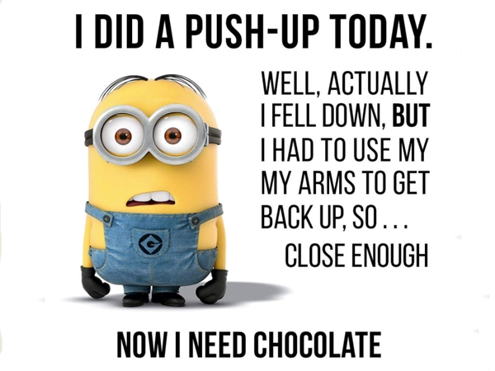***Health Education***

North Tonawanda Middle School

Mrs. Turner Room 162

**Welcome!!!**

Curriculum for Grade 8th

Week 1 Violence Prevention And Total Health

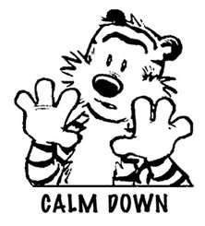

* Stress & Relaxation
* Physical, Mental and Social Health

 Week 2 Physical Activity

* Benefits of fitness
* Components of fitness
* Aerobic and Anaerobic exercise
* Pulse & Target heart rate
* Steroids
* Injury
* Oxygen and your muscles



Week 3 Nutrition and Lifestyle Habits

* Food pyramid
* Nutrients
* Eating disorders
* Fast food and its effect on the body
* Serving sizes
* Lifestyle choices and long term benefits and complications

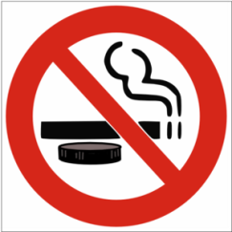

Week 4 Tobacco

* Smoke and smokeless
* Long-term organ health
* Financial cost
* Legality

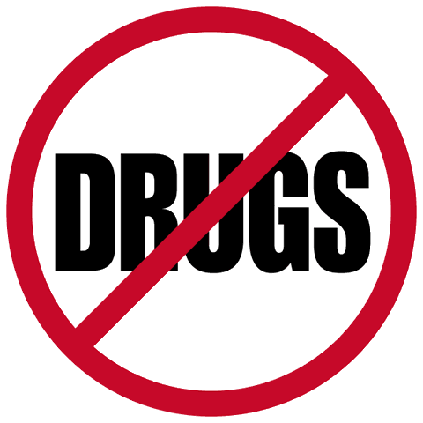

Week 5 Alcohol & Other Drugs

* Effects on the brain
* Drinking and Driving ( DWI)
* Effects on the body systems
* Media influences
* Addiction & Alcoholism

Week 6 Unintentional Injury Prevention and First Aid

[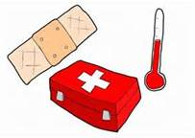](http://www.bing.com/images/search?q=health+euducation&qs=n&form=QBIR&pq=health+euducation&sc=8-17&sp=-1&sk=#view=detail&id=10C69C826CD3CFA26871CC4FCD8703B05A890585&selectedIndex=90)

* Good Samaritan Law
* Wounds
* Sprain, Strains & Fractures
* Heat Stroke
* Babysitting & Emergencies
* CPR

Week 7Family Life/ Sexual Health and Reproduction

* Male and female anatomy review

Week 8 Family Life/Parenting and The Life Cycle



* Pregnancy
* Refusal skills
* Healthy relationships
* Ready or not tot project
* Communication
* Sexuality

Week 9 HIV/AIDS and Sexually Transmitted Disease



* AIDS
* STD’s
* STI’s
* Prevention
* Abstinence
* Internet Safety

Week 10 Career

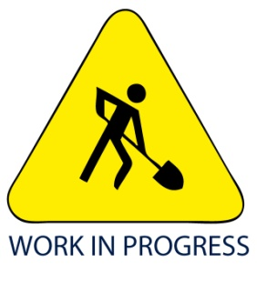

* 5 year plan
* Job Profile
* Resume

Supplies **–** Please have your supplies no later than the 3rd day of health. See your teacher if you are unable to do so.

* Pen or Pencil
* Loose-Leaf Paper
* Two-pocket folder just for HEALTH
* Dry erase marker

Homework

On occasion you will have homework assignments and projects. Most work will be done in class.

Grading

Your grade will be determined by a combination of homework, participation, tests and projects. This class is a chance to get involved and really explore a wide range of topics.

* *Tests*- Students will have 1 quiz about every 2 weeks. Quizzes will be announced ahead of time and will not be a surprise.
* *Projects*- Students will be required to complete projects throughout the marking period. Most of the projects will be done in school and are a great opportunity to receive a high grade.

**\* All missed work must be made up. See the “While you were out wall” in the classroom.**

**Parental Involvement**

Students will receive several assignments that will involve interaction and communication with their parents or guardians. Many sensitive, and sometimes embarrassing, questions come up in the life of an adolescent and he/she should feel comfortable coming to myself ( Mrs. Turner) and/or their parents for advice, comfort and help. We want to keep the line of communication open.

**Discipline**

If a student chooses to misbehave in class, they will receive 1 warning and their name will go on the board. Two warnings and the parent will be called. Three warnings will result in a detention.

**Rules**

**RESPECT**

**RESPECT**

### RESPECT

